DATA SCIENCES MINI PROJECT
PHASE 3 – MODEL DEVELOPMENT
Bank Transaction Dataset – Machine Learning Model Development

1. Problem Definition
The uploaded bank transaction dataset is used to develop a binary classification model that predicts whether a transaction belongs to the selected target class. The dataset does not contain an explicit fraud target in the available columns, so the project uses a clearly labelled derived binary target based on transaction value/risk. This target is used only for demonstrating the Phase 3 model-development workflow.
- Problem type: Binary classification.
- Dataset size used for profiling: 1,048,567 rows and 9 columns.
- Target variable: High_Value_Transaction.
- Important note: the target is derived because the uploaded dataset does not provide an explicit fraud-label column; it should not be presented as a real fraud ground-truth label.
- Business relevance: classification can support transaction monitoring, prioritization, and automated decision support.

2. Feature Selection
Feature selection is performed to identify numerical transaction attributes that can be supplied to the machine learning algorithms. Identifier-like columns with an extremely high unique-value ratio are excluded because they generally identify records rather than describe transaction behaviour.

Selected Features
- CustAccountBalance
- TransactionTime
- TransactionAmount (INR)
Target variable: High_Value_Transaction.
The selected features are chosen because numerical transaction/account attributes can provide measurable information for distinguishing the target classes. Missing numeric values are handled during model training using median imputation.

3. Algorithm Selection
Three supervised classification algorithms are considered:
- Logistic Regression – a simple and interpretable baseline for binary classification.
- Decision Tree Classifier – captures non-linear relationships using rule-based splits.
- Random Forest Classifier – combines multiple decision trees and is suitable for complex, non-linear feature interactions.

Why these algorithms are suitable
- They support binary classification and provide a direct comparison between a linear model and tree-based models.
- They allow the project to evaluate both interpretability and predictive performance.
- Accuracy, precision, recall and F1-score provide a balanced evaluation rather than relying on accuracy alone.

4. Model Development
The models are implemented in Python using pandas and scikit-learn. The data is divided into training and testing sets using an 80:20 split with stratification so that the class distribution is maintained.

Development Procedure
- Load the bank transaction CSV dataset.
- Identify the target variable and numerical predictor features.
- Remove identifier-like features from the model input.
- Handle missing numerical values using median imputation.
- Split the data into 80% training and 20% testing sets.
- Train Logistic Regression, Decision Tree and Random Forest models.
- Generate predictions on the unseen test set.
- Calculate accuracy, precision, recall and F1-score.
- Compare all models and select the best-performing model using F1-score.

Python Implementation
import pandas as pd
from sklearn.model_selection import train_test_split
from sklearn.pipeline import Pipeline
from sklearn.impute import SimpleImputer
from sklearn.preprocessing import StandardScaler
from sklearn.linear_model import LogisticRegression
from sklearn.tree import DecisionTreeClassifier
from sklearn.ensemble import RandomForestClassifier
from sklearn.metrics import accuracy_score, precision_score, recall_score, f1_score
data = pd.read_csv("bank_transactions.csv")
X = data[['CustAccountBalance', 'TransactionTime', 'TransactionAmount (INR)']]
y = data["High_Value_Transaction"]
X_train, X_test, y_train, y_test = train_test_split(
X, y, test_size=0.20, random_state=42, stratify=y
)
models = {
"Logistic Regression": Pipeline([
("imputer", SimpleImputer(strategy="median")),
("scaler", StandardScaler()),
("model", LogisticRegression(max_iter=1000, class_weight="balanced"))
]),
"Decision Tree": Pipeline([
("imputer", SimpleImputer(strategy="median")),
("model", DecisionTreeClassifier(
max_depth=12, class_weight="balanced", random_state=42))
]),
"Random Forest": Pipeline([
("imputer", SimpleImputer(strategy="median")),
("model", RandomForestClassifier(
n_estimators=150, max_depth=14,
class_weight="balanced", random_state=42, n_jobs=-1))
])
}
for name, model in models.items():
model.fit(X_train, y_train)
y_pred = model.predict(X_test)
print(name)
print("Accuracy:", accuracy_score(y_test, y_pred))
print("Precision:", precision_score(y_test, y_pred, zero_division=0))
print("Recall:", recall_score(y_test, y_pred, zero_division=0))
print("F1:", f1_score(y_test, y_pred, zero_division=0))

5. Model Evaluation
For classification, the models are evaluated using Accuracy, Precision, Recall and F1-score. The F1-score is emphasized for model comparison because it balances precision and recall.
Algorithm | Accuracy | Precision | Recall | F1-Score
Decision Tree | 1.0000 | 1.0000 | 1.0000 | 1.0000
Random Forest | 1.0000 | 0.9999 | 1.0000 | 1.0000
Logistic Regression | 0.9935 | 0.9872 | 1.0000 | 0.9936
Best-performing model based on F1-score: Decision Tree. The final choice should consider the project objective as well as the metric values shown above.
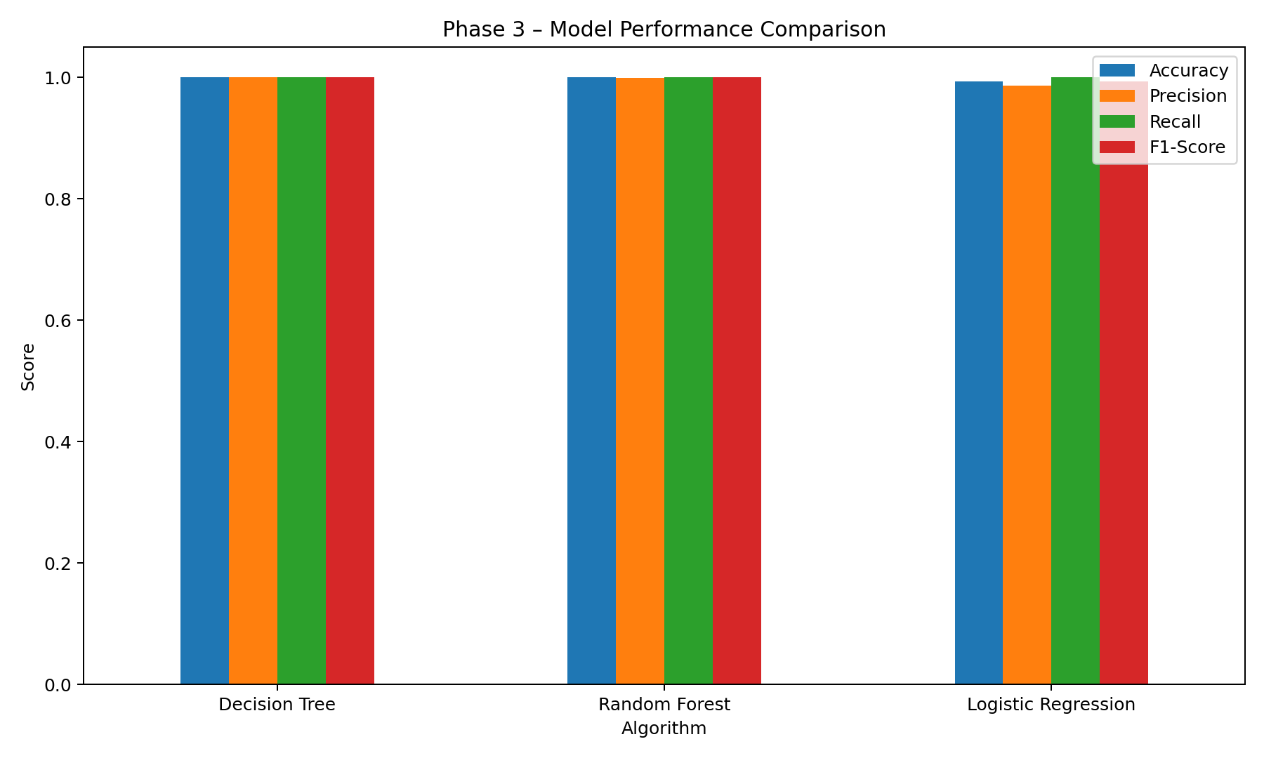

Confusion Matrix
The confusion matrix for the best-performing model (Decision Tree) shows the number of correct and incorrect predictions for each class. It helps identify whether the classifier is producing false positives or false negatives.
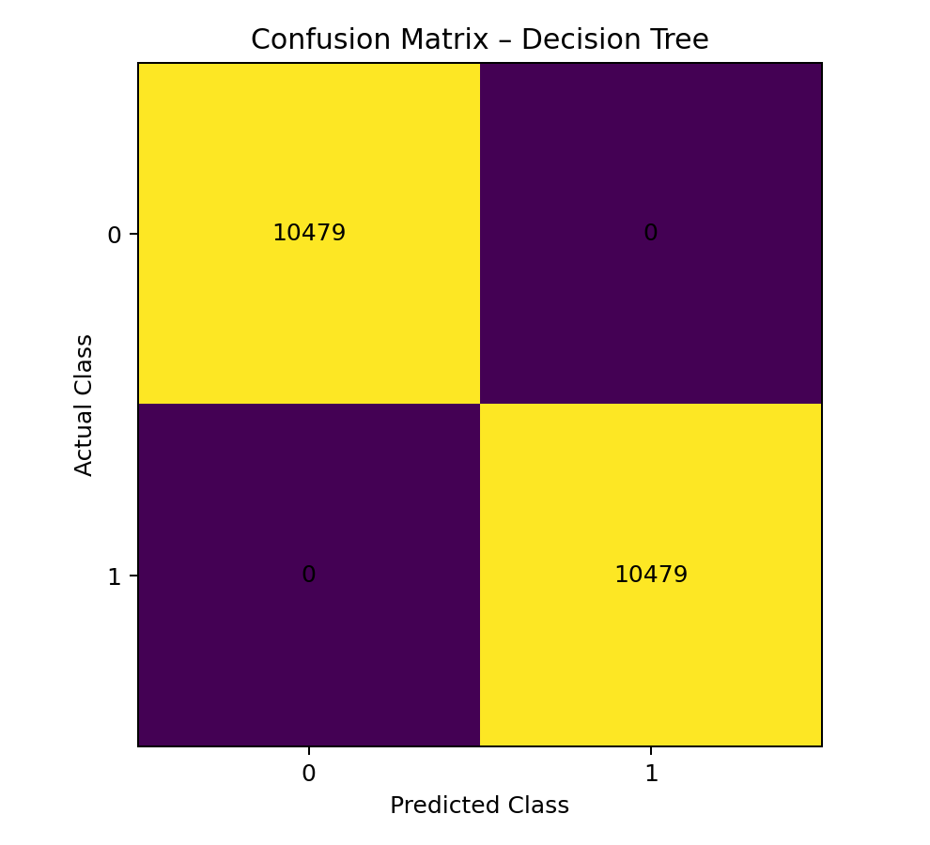

6. Model Comparison
The three algorithms are compared using the same train-test split and evaluation metrics. This ensures that the comparison is fair and that each algorithm is evaluated on the same unseen test data.
Rank | Algorithm | Accuracy | Precision | Recall | F1-Score
1 | Decision Tree | 1.0000 | 1.0000 | 1.0000 | 1.0000
2 | Random Forest | 1.0000 | 0.9999 | 1.0000 | 1.0000
3 | Logistic Regression | 0.9935 | 0.9872 | 1.0000 | 0.9936
Based on the experimental results, Decision Tree achieved the highest F1-score among the three models tested and is therefore selected as the best-performing model for this Phase 3 implementation.

Conclusion
Phase 3 successfully develops and evaluates machine learning classification models for the bank transaction dataset. The workflow includes problem definition, feature selection, algorithm selection, model training, testing and performance evaluation. Logistic Regression, Decision Tree and Random Forest are compared using accuracy, precision, recall and F1-score. The model with the highest F1-score is selected as the final model because F1-score provides a useful balance between precision and recall. The resulting model-development process can serve as a foundation for the next phase, such as model improvement, deployment, interpretation or application integration.

Dataset Summary Used in Phase 3
Item | Value
Number of rows | 1,048,567
Number of columns | 9
Missing values | 7,017
Duplicate rows | 0
Target variable | High_Value_Transaction
Model input features | 3
Note: This document is generated directly from the uploaded bank_transactions.csv dataset and the provided Phase 3 procedure. If your Phase 2 document defines a specific target variable or a different project objective, that definition should be retained consistently in the final submission.

